Voice Coach — Análisis de voz
Idioma: English · Duración: 1m 3s · Palabras: 134 · Ritmo: 127 ppm · Positividad: 70% · Muletillas: 0 · Generado: 7/10/2026, 11:51:24 PM

Métricas
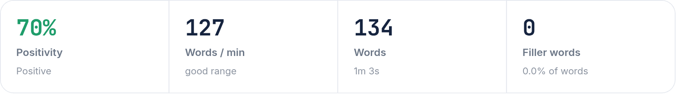

Arco de sentimiento
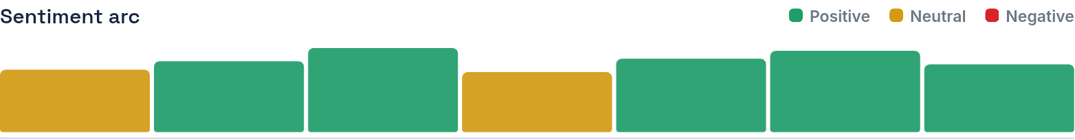

Transcripción
I prefer to work for a bit company because you can move to different positions and build a career path. For example, you can start as a trainee and work your way up to CEO. Additionally, it's a good reference for working at other companies. Two, I disagree that technology has improved communication because in a face-to-face meeting, you can identify people's reactions until whether an answer is through food. For example, in a distant association, it's very important to close deals in person. Three, I decide to pursue an MBA at the UCP because it's the best university in Peru and it has been partnership with the USA. For example, at the end of the program, I will go to USA to take some classes and apply for my degree in New Orleans.
Color del texto — Verde: positivo · Amarillo: neutral · Rojo: negativo

